AquaChain Production Development Plan Report
Team 1: Rachana Bangalore Nagaraju, Shruti Kalyanaraman, Mihir Kavishwar, Patrick Okimi, William Lopez
Department of Industrial and Systems Engineering
University of Southern California
ISE 585: Strategic Management of Technology and Innovation, Spring 2024
Instructor: Paul Lu
Due Date: Apr 5, 2024

Table of Contents
Table of Contents
Aggregate Planning
Demand Forecasting
Production Capacity and Resources
Inventory Management
Production Planning and Scheduling
Supply Chain Management
Financial Planning and Analysis
Risk Management
Performance Measurement and Monitoring
Sales and Operations Planning
Sales Forecast
Key Activities
Operations
Material Requirements Planning (MRP)
Enterprise Resource Planning (ERP):
Short-term Planning

Aggregate Planning
Most of our customers have smart meter sensors in place and we just provide SaaS to them. For an exception few, where the utility companies do not have smart sensors, we provide the sensors from a third party sensor who are an original equipment manufacturer (OEM) and also install sensors in the network. So, we are making an aggregate plan only in case of an exception where the utility company does not have smart sensors. The workforce, the units considered here are this special case. As far as our core offering is concerned, the plan for server capacity, the APIs used and the subscription and pricing model is considered.

Demand Forecasting
- Forecasted Demand for the next year: 1000 units of water management systems

Production Capacity and Resources
- Production Capacity: 400 units per month
- Third-party company workforce for manufacturing sensors: 20 full-time employees
- Equipment: Sufficient to meet production capacity

Inventory Management
- Target Finished Goods Inventory: 2,00 units

Production Planning and Scheduling
Monthly Production Plan (From Sales forecast)
Q1: January to March | 250
Q2: April to June | 246
Q3: July to September | 262
Q4: October to December | 242

Supply Chain Management
- Raw Material Lead Time: 1 month
- Safety Stock for Raw Materials: 20% of monthly usage
- Establish a partnership with a reliable sensor manufacturer offering industrial-grade water quality sensors with a proven track record.
- Negotiate bulk purchase agreements with the sensor manufacturer for a 10% discount.

Financial Planning and Analysis

Cost per unit
Total Cost per Unit | $158.62

Selling price
Selling Price per Unit | $174.48

Expected Revenue
2024 | $174,480.00

Expected Production Cost
Total operating Expenses | $520,321

Expected Profit
Net Income | -$492,290.93

Risk Management

Identified Risks
Supply chain disruptions, regulatory changes

Contingency Plans
Alternative suppliers, diversification of product offerings

Performance Measurement and Monitoring

Key Performance Indicators
- Production Efficiency: 90%
- Inventory Turnover Ratio: 6 times per year
- Customer Satisfaction: 95%

This aggregate plan provides a basic framework for AquaChain's production and inventory management activities over the next year. It considers forecasted demand, production capacity, inventory targets, supply chain logistics, financial analysis, risk management, and performance monitoring.

Sales and Operations Planning

Sales Forecast

Target Units
- 1000 AquaChain subscriptions (including optional sensor add-on) with a 20% take rate for the sensor add-on (estimated 200 sensors sold).

Target Market
- Primary: Utility companies managing a minimum of 50,000 customer connections. (Target 50 companies)
- Secondary: Municipalities with a population exceeding 100,000. (Target 20 municipalities)

Competitor Analysis:
- Identify and research the top 3-5 competitors offering similar water management software and sensor solutions.
- Analyze their:
  - Geographic reach & market share.
  - Features & pricing models.
  - The customer base overlaps AquaChain's target markets.

Sales Channels
- Direct Sales Team: 5 - 10 dedicated sales representatives focused on utility companies.
- Partnerships with Technology Providers: Collaboration with 2 major water industry technology providers.
Forecasting Outputs:
- Unit Sales Forecast (Year 1):
  - Primary Market (Utilities): Assuming 9,000 target utilities & a 10% adoption rate.
  - Secondary Market (Municipalities): Assuming 1000 target municipalities & a 1% market penetration, forecast 10 new municipal customers in year 1.
- Sensor Add-on Sales Forecast (Year 1):
  - Assume a 25% take rate for the sensor add-on among AquaChain subscribers.
- High and Low Forecast Scenarios:
  - High Scenario: Increase adoption rates by 5% for each market segment.
  - Low Scenario: Decrease adoption rates by 1% for each market segment.

Key Activities

Marketing & Sales (Months 1-3)
- Develop case studies showcasing successful AquaChain pilot deployments.
- Train the sales team to highlight AquaChain's USP.
- Identify and qualify 70 potential customers (50 utilities + 20 municipalities) through industry events with a 2% conversion rate.

Pilot Deployments (Months 4-6)
- Secure 5 pilot deployments with utility companies managing over 1 million customer connections.
- Collaborate with partners to implement AquaChain.
- Gather feedback through user surveys with a target 80% satisfaction rate.

Product Development & Improvement (Ongoing)
- Integrate a new feature for leak detection and prediction based on sensor data.
- Develop a mobile app for field personnel to access real-time water quality.

Customer Onboarding & Support (Ongoing)
- Develop a streamlined onboarding process.
- Establish a dedicated customer support team.
- Conduct in-person training sessions for key customer personnel.

Operations

Capacity & Capability Planning (Months 1-2)
- Hire 3 - 5 additional software developers to support new feature addition.
- Upgrade server infrastructure to accommodate the increased data volume.
- Secure a partnership with a cloud service provider to ensure scalability.

Master Production Schedule (Months 3-4)
- Schedule sensor procurement based on confirmed customer orders, with a lead time of 2 months for sensor manufacturing and delivery.

Detailed Planning & Execution (Months 5 onwards)
- Develop detailed project plans for customer deployment, targeting a 4-week window from contract signing to complete system installation and training.
- Execute deployments according to the established plan, with a target 95% on-time completion rate.

Material Requirements Planning (MRP)
Determine the bill of materials for IoT devices and blockchain hardware. Schedule production based on inventory levels and procurement lead times. Coordinate with suppliers for the timely delivery of necessary components.

Master Production Schedule:

Month | 2024 | 2025 | 2026 | 2027 | 2028 | 2029 | 2030 | 2031 | 2032 | 2033
January | 84 | 164 | 262 | 301 | 497 | 569 | 630 | 692 | 753 | 815
February | 76 | 148 | 237 | 273 | 450 | 515 | 570 | 626 | 682 | 737
March | 90 | 176 | 281 | 323 | 533 | 610 | 675 | 741 | 807 | 873
April | 96 | 187 | 300 | 344 | 568 | 650 | 721 | 791 | 861 | 931
May | 80 | 156 | 250 | 287 | 474 | 542 | 600 | 659 | 718 | 776
June | 70 | 137 | 218 | 251 | 414 | 474 | 525 | 577 | 628 | 679
July | 86 | 168 | 268 | 309 | 509 | 582 | 645 | 708 | 771 | 834
August | 96 | 187 | 300 | 344 | 568 | 650 | 721 | 791 | 861 | 931
September | 80 | 156 | 250 | 287 | 474 | 542 | 600 | 659 | 718 | 776
October | 76 | 148 | 237 | 273 | 450 | 515 | 570 | 626 | 682 | 737
November | 86 | 168 | 268 | 309 | 509 | 582 | 645 | 708 | 771 | 834
December | 80 | 156 | 250 | 287 | 474 | 542 | 600 | 659 | 718 | 776
Total Units | 1,000 | 1,950 | 3,120 | 3,588 | 5,920 | 6,773 | 7,505 | 8,238 | 8,970 | 9,702

Bill of Materials:

Item # | Part Group | Item | Unit Cost | Quantity | Total Cost
1 | Meter Housing | Steel Metal | $11.50 | 1 | $11.50
2 | Plumbing | Seals | $1.00 | 2 | $2.00
3 | Plumbing | Clamps | $1.00 | 1 | $1.00
4 | Fasteners | Screws | $0.10 | 8 | $0.80
5 | Fasteners | Nuts | $0.10 | 8 | $0.80
6 | Fasteners | Bolts | $0.10 | 8 | $0.80
7 | Electronics | Circuit Board | $10.00 | 1 | $10.00
8 | Electronics | Wires | $1.00 | 4 | $4.00
9 | Electronics | Microcontroller | $20.00 | 1 | $20.00
10 | Electronics | LCD Display | $10.00 | 1 | $10.00
11 | Electronics | Flow meter | $10.00 | 1 | $10.00
12 | Electronics | Electrochemical Sensor | $10.00 | 1 | $10.00
13 | Electronics | Antenna | $10.00 | 1 | $10.00
14 | Electronics | AC Power Cord | $5.00 | 1 | $5.00
15 | Electronics | AC Power Extensions | $2.00 | 1 | $2.00
 |  |  | Total: | 40 | $97.90

Inventory Available:

Purchase Orders:

Lead Time:

Enterprise Resource Planning (ERP):
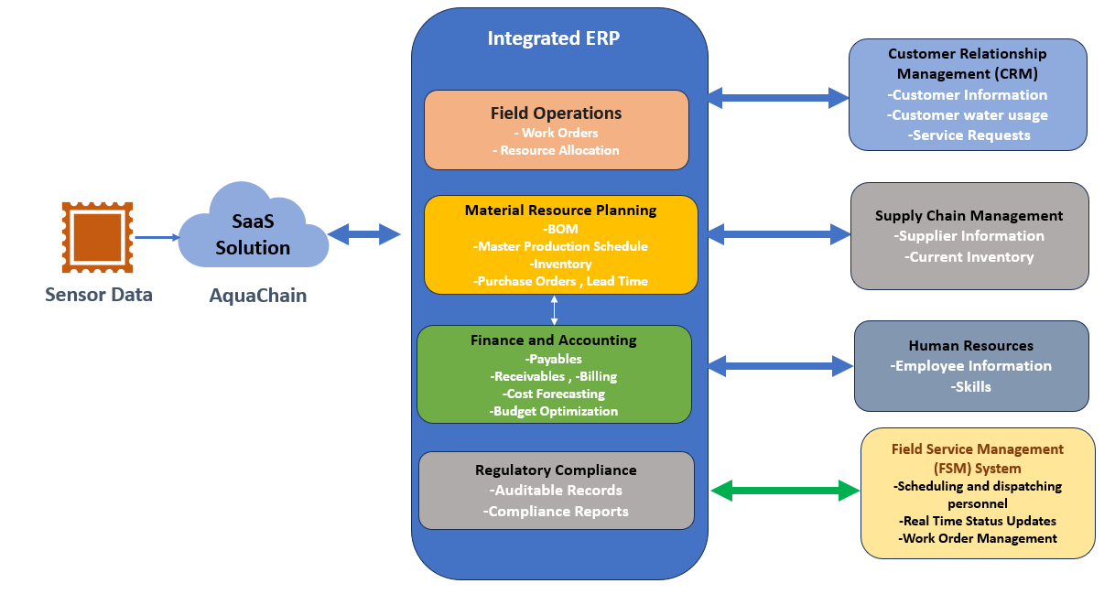
Architecture Overview : The model integrates with AquaChain's cloud-based platform, which collects real-time water quality and usage data from deployed IoT sensors. This data is then disseminated to relevant departments within the ERP system, Customer Relationship Management (CRM),Supply Chain Management(SCM) and Field Service Management(FSM) enabling informed decision-making, optimized resource allocation, and enhanced water management practices.
System Components and Data Flow:
- AquaChain Platform (Cloud-Based):
  - Function: Captures and analyzes water quality and usage data.
  - Data Flow: Sends analyzed data and alerts to relevant ERP modules.
- Integrated ERP System:
  - Field Operations:
    - Function: Manages maintenance tasks based on sensor data.
    - Data Flow: Receives work orders and sends updates to FSM.
  - Inventory Management (within MRP):
    - Function: Tracks inventory levels and facilitates purchase orders.
    - Data Flow: Receives real-time inventory data and sends purchase order requests to SCM.
  - Material Requirements Planning (MRP):
    - Function: Calculates material needs for water production.
    - Data Flow: Receives inventory and usage data, sends purchase order requests to SCM.
  - Finance & Accounting:
    - Function: Manages financial aspects and optimizes budgets.
    - Data Flow: Receives projected costs and invoices, sends budget constraints.
  - Regulatory Compliance:
    - Function: Maintains auditable records for compliance.
    - Data Flow: Receives water quality data.
  - Human Resources:
    - Function: Organizes employee data, ensures regulatory compliance, and facilitates resource allocation.
    - Data Flow: Receives updates on employee skills, maintains a database, and transmits relevant technician data to Field Operations.
- Other Connected Systems:
  - CRM:
    - Function: Handles customer billing and water conservation.
    - Data Flow: Receives usage data, sends invoices and conservation campaigns.
  - SCM:
    - Function: Manages procurement of materials.
    - Data Flow: Receives purchase orders, tracks orders, and manages inventory.
  - FSM:
    - Function: Optimizes scheduling and dispatch.
    - Data Flow: Receives service requests, dispatches technicians, and updates work orders.
Communication Protocol: We utilize APIs: Mulesoft for secure data exchange between modules
Decision Making and Action :Based on reports and insights, informed decisions are made across departments. Actions are taken to optimize water management, resource allocation, customer service, regulatory compliance, and supply chain efficiency.

Short-term Planning
Use the master production schedule to develop detailed plans and activities. Manage the workflow of AquaChain production as job assignments, allocating tasks to individuals or teams for implementation. Prioritize activities based on methods such as First-In-First-Out (FIFO) or Shortest Processing Time (SPT).

The purpose of this short-term production plan is to outline the objectives and strategies for producing AquaChain units over the next year. This plan aims to ensure efficient resource allocation, timely production, and responsiveness to market demands. AquaChain’s short term plan for the next year is presented in the table below.

Month | Units | Capacity Assessment | Resource Allocation
Jan. | 84 | Evaluate available resources for software development, sensor manufacturing, and assembly | ~ Platform Maintenance: 2 Software  developer(s)  ~ Sensor Component Delivery: 1 Supply chain  manager(s)  ~ Ad Hoc: Assembly tasks
Feb. | 76 | Evaluate resource availability against production targets | ~ Gathering Customer Feedback: 1 Software  developer(s)  ~ Supplier Coordination: 2 Supply chain  manager(s)  ~ Ad Hoc: Check potential bottlenecks
Mar. | 90 | Review and adjust resource allocation as necessary | ~ Implementation of New Features: 1 Software  developer(s)  ~ Inventory Management: 1 Supply chain  manager(s)  ~ Ad Hoc: Asses workload/Worker requirements
Apr. | 96 | Ensure optimal resource utilization | ~ Bug Fixes & Optimization: 2 Software  developer(s)  ~ Manage Supplier Relationships: 1 Supply  chain manager(s)  ~ Ad Hoc: Prepare for increased demand
May | 80 | Assess resource availability | ~ Address Performance Issues: 2 Software  developer(s)  ~ Track Shipments & Expedite Deliveries: 1  Supply chain manager(s)  ~ Ad Hoc: Evaluate requirements
June | 70 | Ensure optimal resource utilization | ~ User Testing & Feedback: 2 Software  developer(s)  ~ Track Shipments & Expedite Deliveries: 1  Supply chain manager(s)  ~ Ad Hoc: Evaluate requirements
July | 100 | Review and adjust resource allocation to meet production targets. | ~ Implementation of New Features &  Optimization: 2 Software developer(s)  ~ Ensure Timed Delivery of Componentes: 1  Supply chain manager(s)  ~ Ad Hoc: Support increased production demand
Aug. | 110 | Assess resource utilization and adjust as necessary to meet production targets. | ~ Software Maintenance & Performance  Enhancements : 2 Software developer(s)  ~ Monitor Inventory Levels & Supplier  Relationships: 1 Supply chain manager(s)  ~ Ad Hoc: Support increased production demand
Sep. | 95 | Evaluate resource availability and make adjustments to optimize production. | ~ Implement Customer Requested Features &  Address Bugs: 2 Software developer(s)  ~ Ensure Smooth Logistics and Timely  Procurement: 1 Supply chain manager(s)  ~ Ad Hoc: Support production requirements
Oct. | 105 | Review production processes and resource allocation for efficiency improvements. | ~ Enhance User Experience & Interface  Design: 2 Software developer(s)  ~ Minimize Lead Times & Costs: 1 Supply  chain manager(s)  ~ Ad Hoc: Align with production targets
Nov. | 90 | Analyze production data to identify areas for optimization and improvement. | ~ Performance Tuning & Stability  Enhancements : 2 Software developer(s)  ~ Ensure Supply Chain Efficiency: 1 Supply  chain manager(s)  ~ Ad Hoc: Support increased production demand
Dec. | 100 | Ensure all resources are optimized to meet end-of-year production targets. | ~ Prepare for End of Year Updates: 2 Software  developer(s)  ~ Manage Inventory & Prepare for Holiday  Challenges: 1 Supply chain manager(s)  ~ Ad Hoc: End of year production spikes
*Tasks highlighted in red represent high priority actions and Ad Hoc’s highlighted in orange represent low-medium priority actions

The short-term production plan for AquaChain is structured to meet monthly production targets effectively while ensuring timely delivery and meeting market demand. Key resource allocation strategies focus on software development and supply chain management. Skilled developers are dedicated to tasks such as maintenance, feature implementation, and performance optimization, ensuring continuous improvement of AquaChain's functionality. Additionally, strategic coordination with suppliers is prioritized to secure timely procurement of components and maintain an efficient supply chain, thus minimizing production delays. Augmentation considerations include the potential utilization of temporary workers for assembly tasks, particularly during periods of increased demand, to ensure smooth production flow and meet targets efficiently. Worker numbers are continuously monitored and adjusted to align with production demands and workload fluctuations, optimizing resource utilization. Overall, the production plan emphasizes agility, responsiveness to market dynamics, and a commitment to maximizing efficiency while meeting customer expectations and sustaining continuous improvement in AquaChain's production processes.

